Steps to Follow **Online Fee Pay** App Usage

**1. Install the OnlineFeePay app in your mobile using APK file**

**2. Tab on Online Fee pay app Icon to open the app so that below welcome screen will dhT,isplay**



**Figure 1 Welcome**

**3. Enter default username and password [admin, admin] for login**

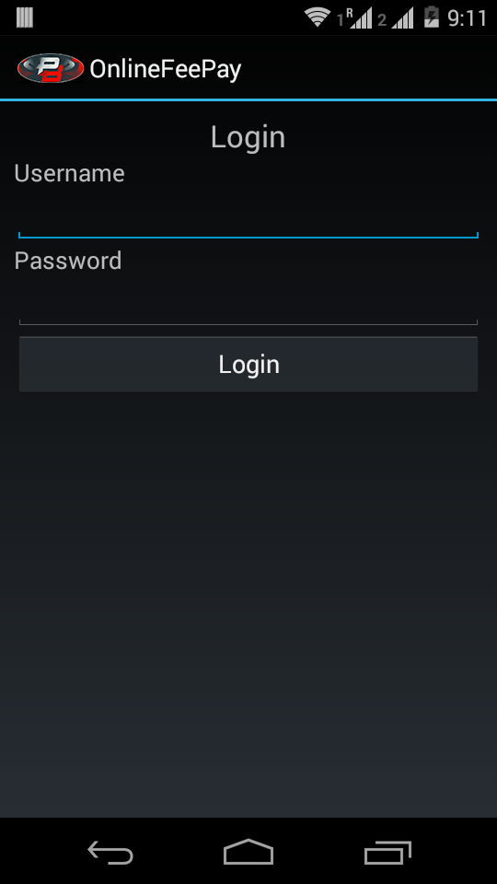

**Figure 2 Login**

Three type of login available they are

1. Admin
2. Student
3. Parent

Admin having following options

1. Create user
2. Parent creation
3. Bank account creation
4. Exam fee creation
5. Generate exam fee
6. View status
7. Logout

Student having following options

1. View status
2. Fee pay
3. Logout

Parent having following options

1. View status
2. Logout

**4. Student Creation option**

Open create user followed by feed input data for used creation and press the create user button

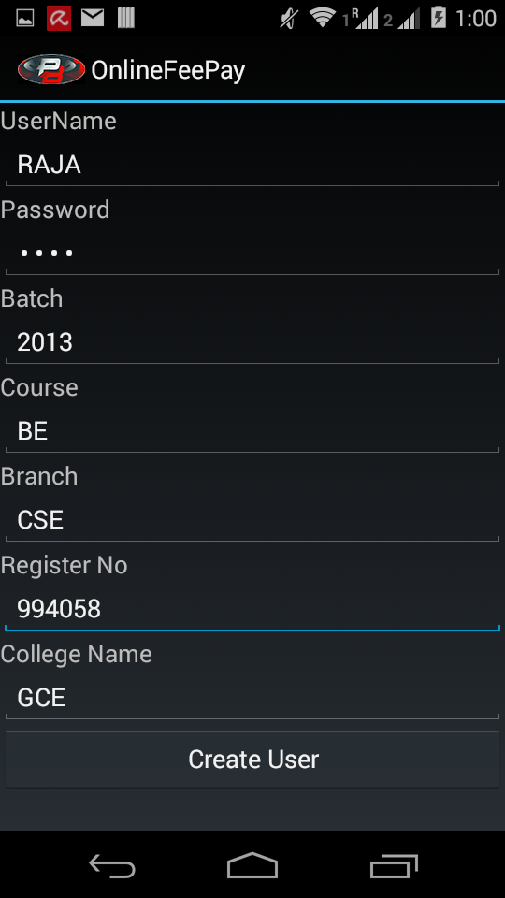

**Figure 3 Student Creation**

**5. Parent creation**

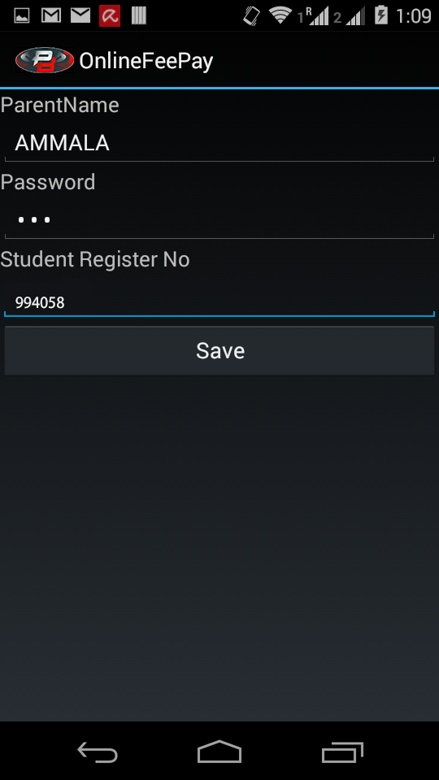

**Figure 4 Parent Creation**

Enter parent name, password and student register no

Note

Register no is the key for maping student and parent for viewing student fee status so, student and parent register no will be same

**6. Bank account creation**

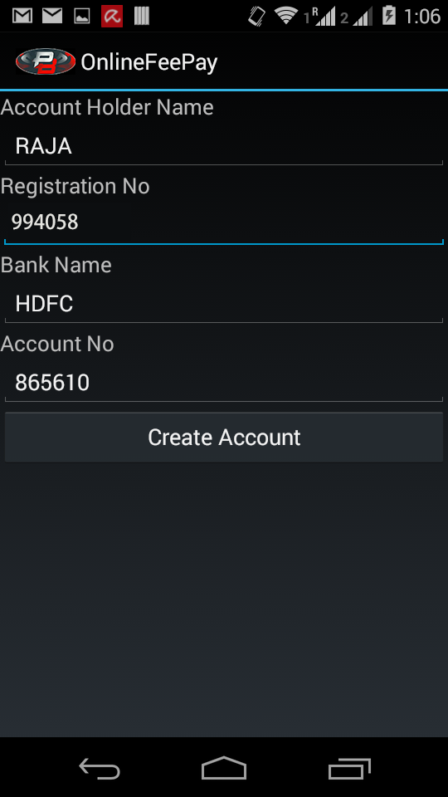

**Figure 5 Bank Account Creation**

Click bank account creation followed by feed data for bank account creation

**7. Fee creation**

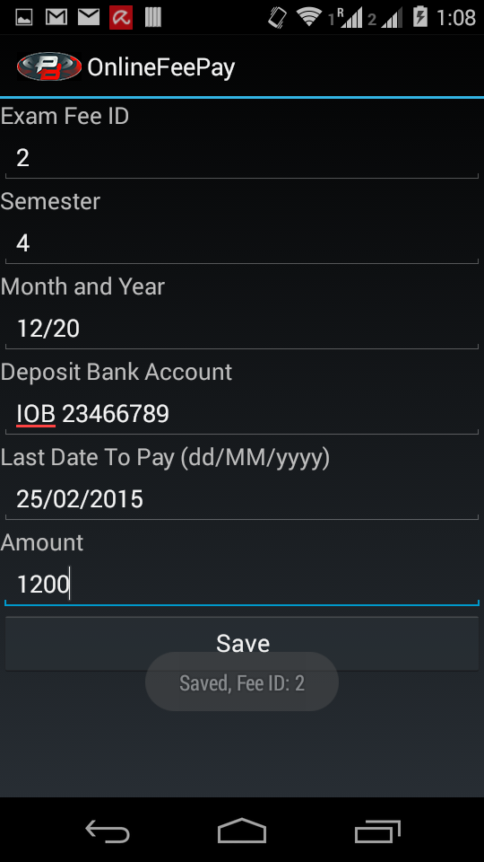

**Figure 6 Fee Creation**

Click fee creation option provide data to fee creation

Remember that fee ID is unique

**8. Generate exam fee**

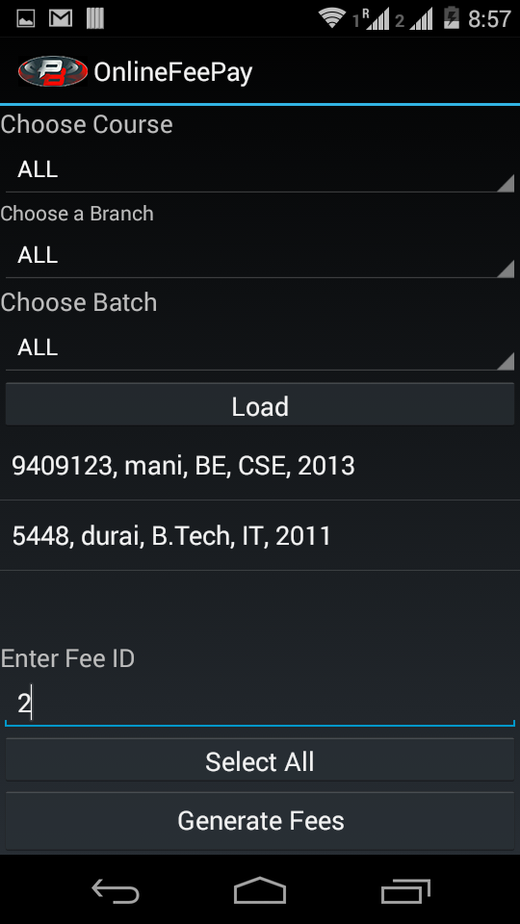

**Figure 7 Generate Fee**

Exam fee will load the student data

Enter fee ID we already created in fee ID field

When administration press the generate fee option then the fee will created based on we already created fee details

And also alert notification will be sent to all available users

**9. View status**

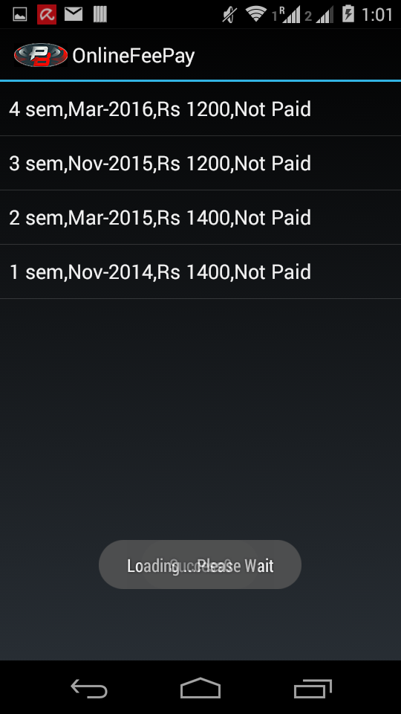

**Figure 8 View Fee Status**

Using view status option

Admin can saw who are paid or not paid

Student can saw only their exam fee status

Parent can saw when parent creation time mapped student exam fee status

**10. Fee pay**

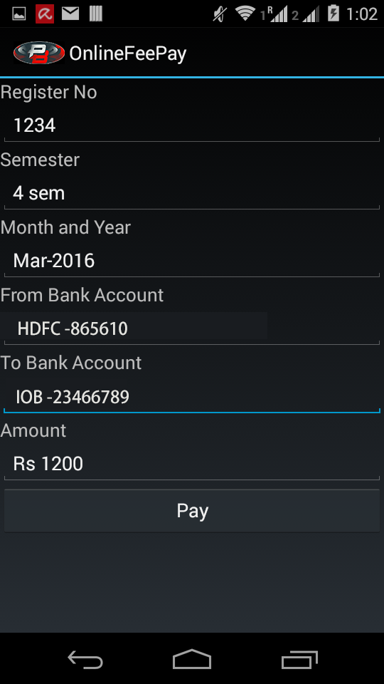

**Figure 9 Pay Exam Fee**

User fee status viewing time he can click and long press the row than followed by he can verify the detail and pay the exam fees

**11. Backend View**

Go to parse.com and click login option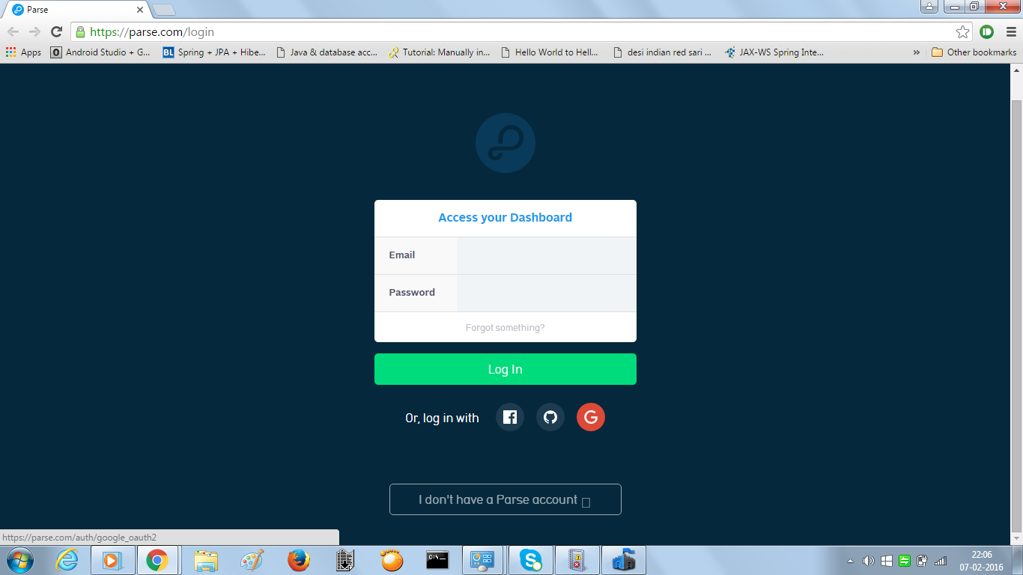

**Figure 10 Parse.com login Page**

**12. App Selections**

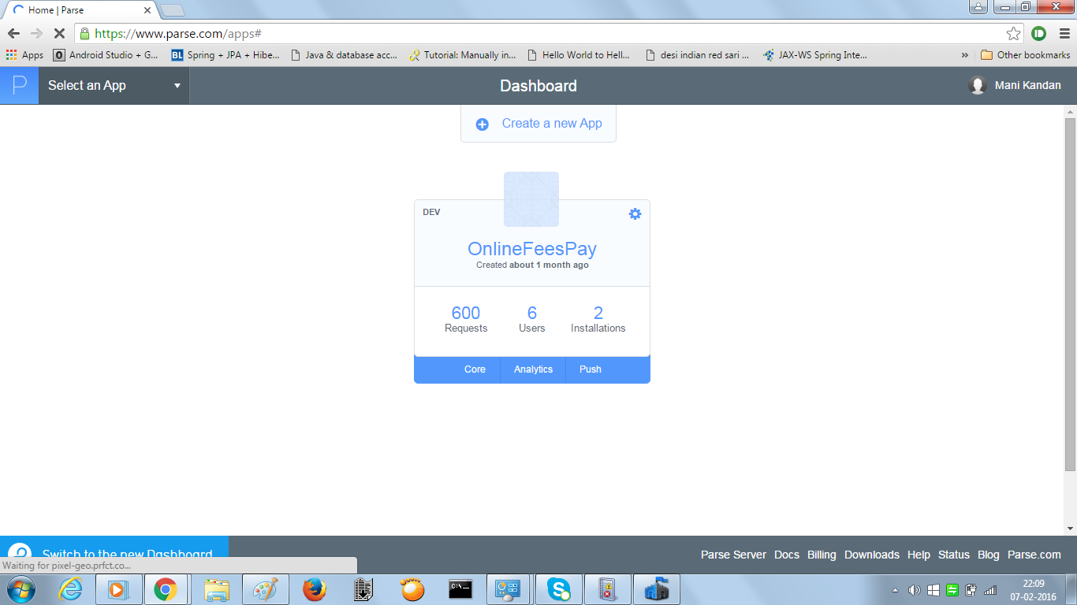

**Figure 11 Select the Application**

**13. Go Data Tab to View Database Tables**

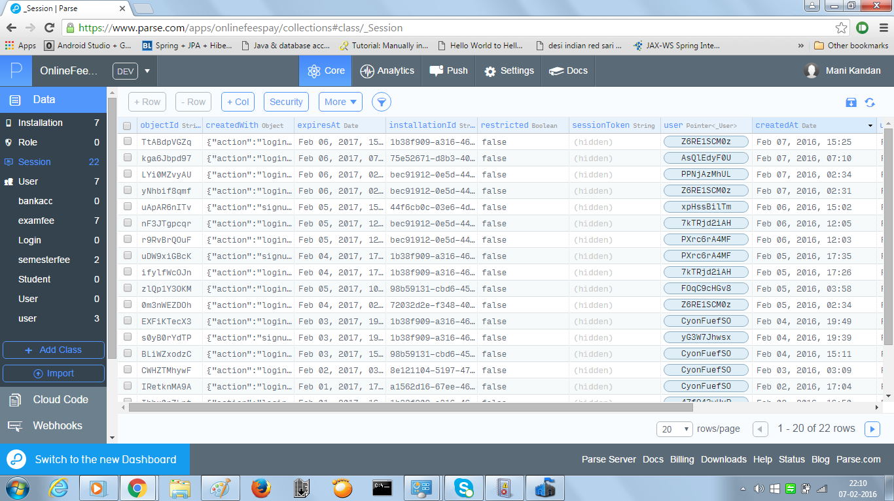

**Figure 12 Viewing Database Table Data**